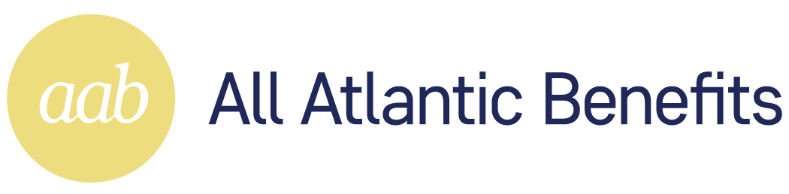
All Atlantic Benefits, LLC | 200 S Park Road, Suite 475, Hollywood, FL 33021 | Phone: 305-809-8211 | Fax: 305-240-6119

Notice to Enrollees Regarding Opt-Out
Group health plans sponsored by State and local governmental employers must generally comply with Federal law requirements in title XXVII of the Public Health Service Act. However, these employers are permitted to elect to exempt a plan from the requirements listed below for any part of the plan that is "self-funded" by the employer, rather than provided through a health insurance policy. [Name of plan sponsor] has elected to exempt [name of plan] from [all or specify which ones] of the following requirements:
- Protection against limiting hospital stays in connection with the birth of a child to less than 48 hours for a vaginal delivery, and 96 hours for a cesarean section.
- Protections against having benefits for mental health and substance use disorders be subject to more restrictions than apply to medical and surgical benefits covered by the plan.
- Certain requirements to provide benefits for breast reconstruction after a mastectomy.
- Continued coverage for up to one year for a dependent child who is covered as a dependent under the plan solely based on student status, who takes a medically necessary leave of absence from a postsecondary educational institution.
The exemption from these federal requirements will be in effect for the [plan year] [period of plan coverage] beginning [specify date] and ending [specify date]. The election may be renewed for subsequent plan years.

[If the Plan provides protections similar to any of the exempted requirements, either voluntarily or in accordance with State law, those protections may be identified.]

